  - October / 2023
At Three Magnolias, we want our clients to be comfortable with us in planning their financial future and the outcomes they are working to realize.
We do this by:
1. Developing long-term relationships with our clients
2. Persevering with them through their challenges.
3. Celebrating their victories

Ghosts, Goblins, Vampires or Bad Markets:
What Are We to Fear in October?
Fall is in the air! We’ve got Halloween candy on the front desk and we’re picking out our costumes. You know what that means – October is here. Often, I’ll hear from people that they’re not just afraid of werewolves. They’re also afraid of what October brings for the markets. Here we’ll talk about fact vs myth.
One fact is October has been the month with the largest percentage change. Two of our most famous market collapses occurred in October, one on Black Monday 1987 and the other in 1929. But a myth is that October is always bad or even tends to be down. In reality, October has tended to move higher on average for the past 30 years and even boasts the largest percentage monthly gain on average.

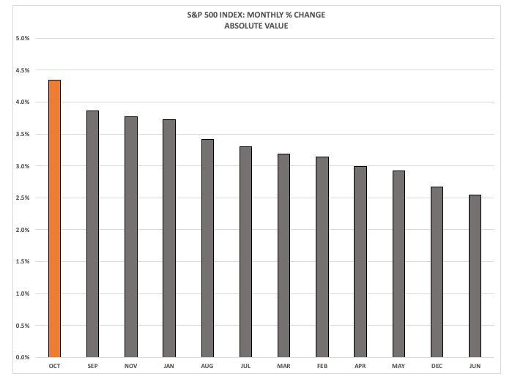
Source (Nasdaq): https://www.nasdaq.com/articles/is-october-the-most-volatile-month-for-the-sp-500-index
Another fact is that while it has the biggest collapses, October also has clocked the largest positive change of any given month over the past 30 years and has often marked the end of a bear market. Market slides in 1987, 1990, 2001, and 2002 turned around in October and began long-term rallies. In particular, Black Monday 1987 was one of the great buying opportunities of the last 50 years.¹
October gets a bad rap primarily because several memorable bad days fall in this month. This is more of a spooky trick our brains play on us rather than a fact. More of us have lived through a higher number of negative Septembers than Octobers.
So, what should you do from here? Well, it would be nice if good or bad times for the market clustered around a specific time of the year. Unfortunately, it’s not that simple; however, there are a few tenants we can live by:
- Remember that it’s time in the market, rather than market timing that works consistently.
- Pay attention to your risk and stay balanced even when it’s unexciting!
- Like a scary horror movie, financial news is made to startle you and get your attention. Watching too much will keep you out of the fun house.
- Don’t let bad markets scare you out of savings! Remember the scariest times may be the time to buy… if you dare!
If you’re still spooked, don’t be afraid to ask for help! Please know that we’re always here for you.
¹ Source (Investopedia): https://www.investopedia.com/articles/financial-theory/09/october-effect.asp
Holiday Hours & Year End Reminders:
- Our office will be closed on Thursday November 23rd and Friday November 24th.
- Most retirement accounts require a minimum distribution for those over age 73.
- If you are contemplating anything with a year end deadline such as a new account or a charitable gift, please notify us prior to Friday, December 8th. It is not uncommon for us to experience year end backlogs on paperwork so please let us know as early as you can.
Contact Us
Three Magnolias Financial Advisors
(Primary)
110 Oakwood Dr., Ste 480
Winston-Salem, NC 27103
Tel: 336.701.1600
Fax: 336.701.0554
(Secondary)
232 Causeway Dr, Ste 2-A
Wrightsville Beach, NC 28480
Tel: 910.496.6048

Email:
jennifer@3-magnolias.com
wes@3-magnolias.com
Website: https://www.threemagnoliasfinancial
advisors.com/

The views stated in this letter are not the necessarily the opinion of Cetera Advisor Networks LLC and should not be construed directly or indirectly as an offer to buy or sell any securities mentioned herein. Due to volatility within the markets mentioned, opinions are subject to change without notice. Information is based on sources believed to be reliable; however, their accuracy or completeness cannot be guaranteed. Past performance does not guarantee future results. Investors cannot invest directly in indexes. The performance of any index is not indicative of the performance of any investment and does not take into account the effects of inflation and the fees and expenses associated with investing. All investing involves risk, including the possible loss of principal. There is no assurance that any investment strategy will be successful.

For a comprehensive review of your personal situation, always consult with a tax or legal advisor. Neither Cetera Advisor Networks LLC nor any of its representatives may give legal or tax advice. Additional risks are associated with international investing, such as currency fluctuations, political and economic stability, and differences in accounting standards.

Jennifer Johnson, Wesley Reed, and Jonathan Kacmarcik are Registered Representatives offering securities offered through Cetera Advisor Networks LLC, member FINRA/SIPC. Investment advisory services offered through Three Magnolias Financial Advisors. Three Magnolias Financial Advisors and Cetera Advisor Networks are not affiliated. Cetera is under separate ownership from any other named entity.

